

Microsoft ADC Cybersecurity Skilling Program

Assignment 19 -AZ-500 Learning Path: Cloud Governance

Student Name: ALEX EVANS NJIRU MBOGO

Student ID: adc-css02-25064

Lab scenario
You have been asked to create a proof of concept application that makes use of the Azure SQL Database support for Always Encrypted functionality. All of the secrets and keys used in this scenario should be stored in Key Vault. The application should be registered in Microsoft Entra ID in order to enhance its security posture. To accomplish these objectives, the proof of concept should include:
- Creating an Azure Key Vault and storing keys and secrets in the vault.
- Create a SQL Database and encrypting content of columns in database tables by using Always Encrypted.
For all the resources in this lab, we are using the East US region. Verify with your instructor this is the region to use for class.
To keep the focus on the security aspects of Azure, related to building this proof of concept, you will start from an automated ARM template deployment, setting up a Virtual Machine with Visual Studio 2019 and SQL Server Management Studio 19.

Lab objectives
In this lab, you will complete the following exercises:
- Exercise 1: Deploy the base infrastructure from an ARM template
- Exercise 2: Configure the Key Vault resource with a key and a secret
- Exercise 3: Configure an Azure SQL database and a data-driven application
- Exercise 4: Demonstrate the use of Azure Key Vault in encrypting the Azure SQL database

Instructions

Exercise 1: Deploy the base infrastructure from an ARM template
In this exercise, i completed the following tasks:
- Task 1: Deploy an Azure VM and an Azure SQL database

Task 1: Deploy an Azure VM and an Azure SQL database
In this task, you will deploy an Azure VM, which will automatically install Visual Studio 2019 and SQL Server Management Studio 19 as part of the deployment.
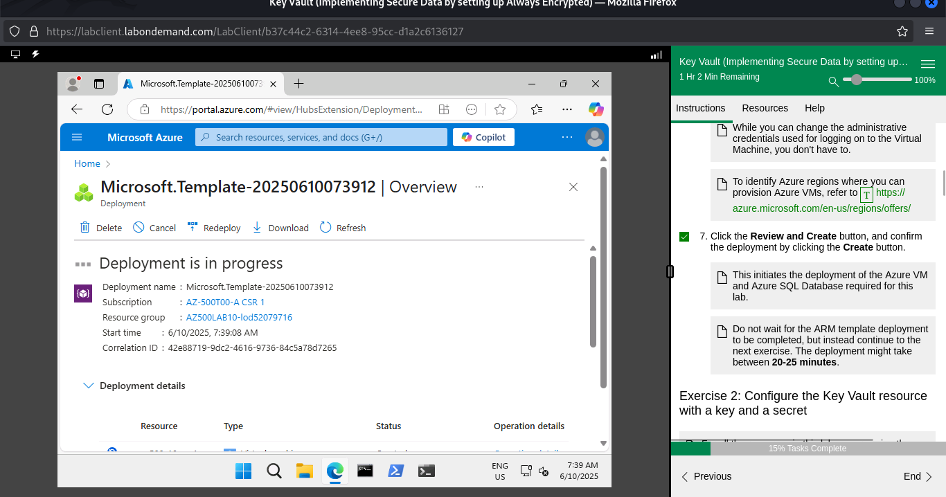

Exercise 2: Configure the Key Vault resource with a key and a secret
In this exercise, I completed the following tasks:
- Task 1: Create and configure a Key Vault
- Task 2: Add a key to the Key Vault
- Task 3: Add a secret to the Key Vault

Task 1: Create and configure a Key Vault
In this task, you will create an Azure Key Vault resource. You will also configure the Azure Key Vault permissions.
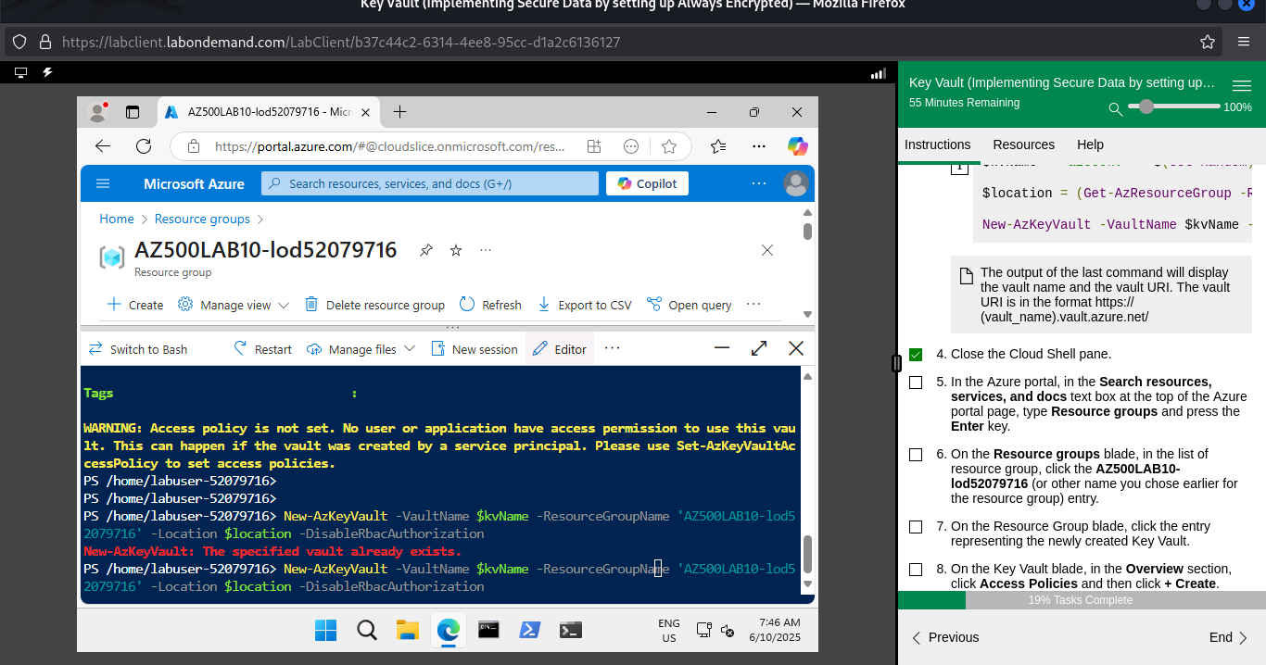
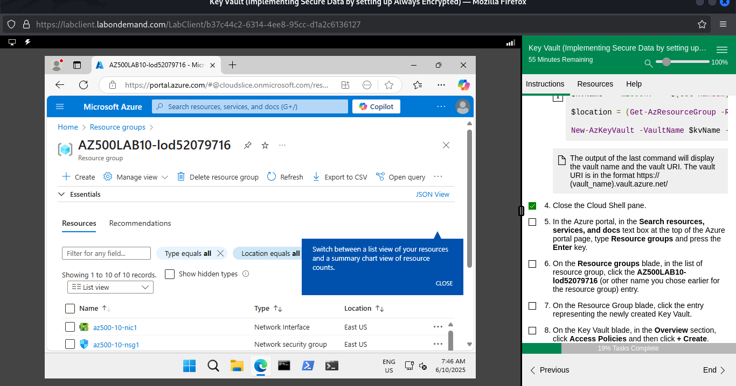
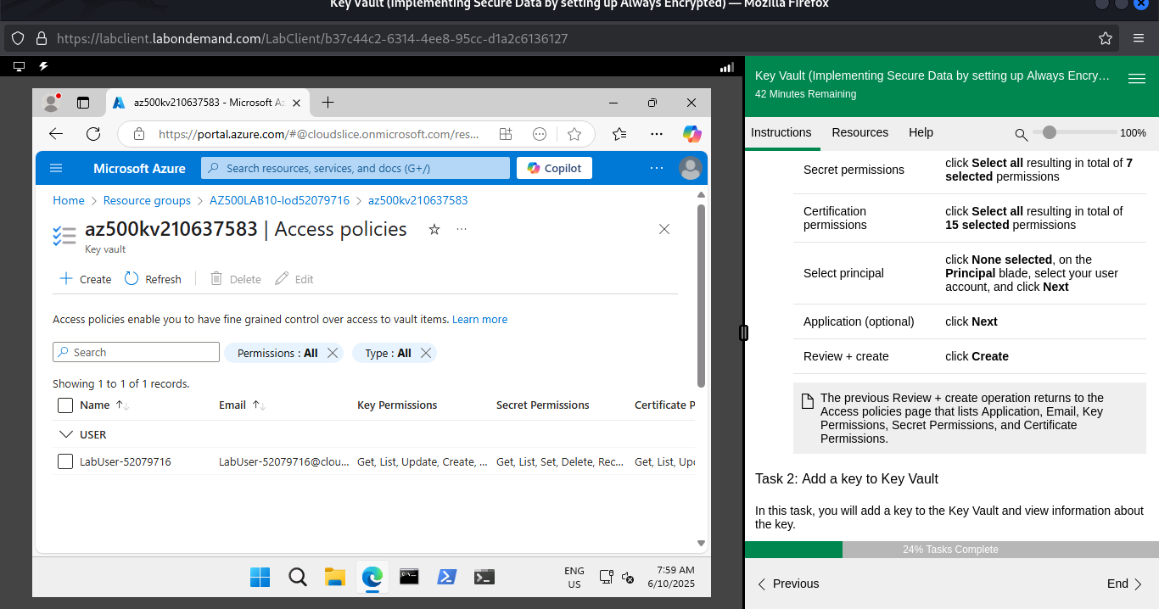

Task 2: Add a key to Key Vault
In this task, you will add a key to the Key Vault and view information about the key.
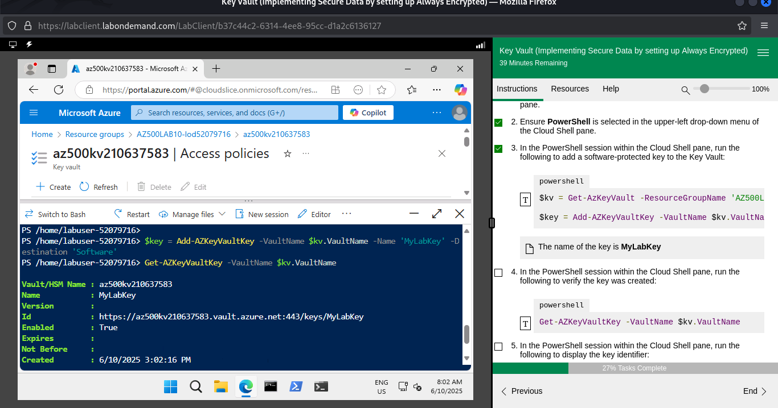
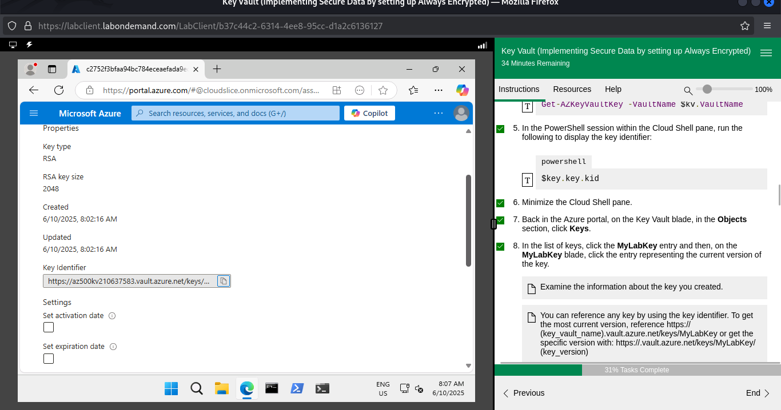

Task 3: Add a Secret to Key Vault
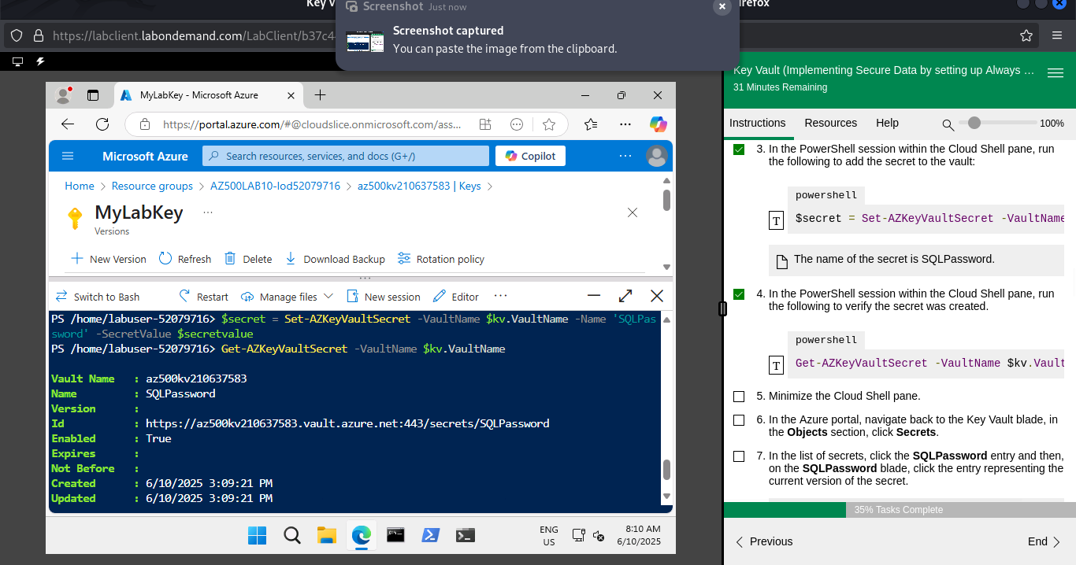
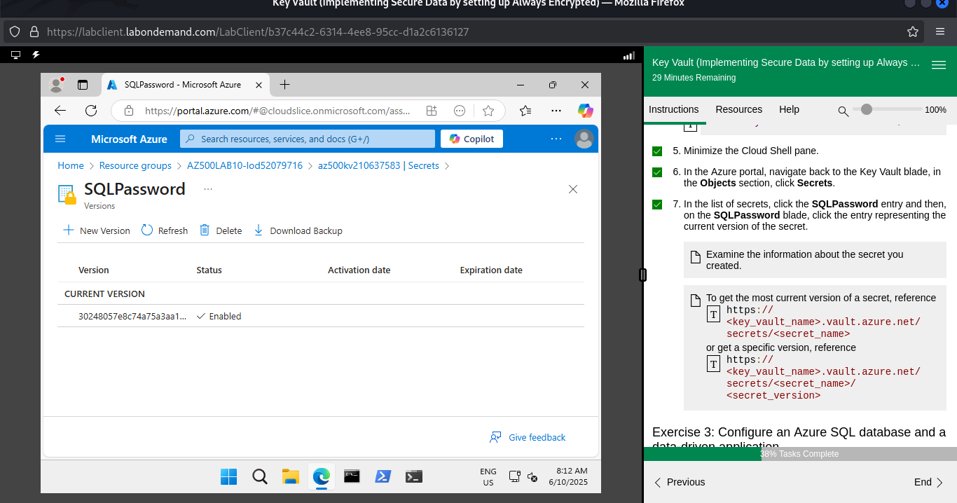

Exercise 3: Configure an Azure SQL database and a data-driven application
In this exercise, I completed the following tasks:
Task 1: Enable a client application to access the Azure SQL Database service.
- Task 2: Create a policy allowing the application access to the Key Vault.
- Task 3: Retrieve SQL Azure database ADO.NET Connection String
- Task 4: Log on to the Azure VM running Visual Studio 2019 and SQL Management Studio 19
- Task 5: Create a table in the SQL Database and select data columns for encryption

Task 1: Enable a client application to access the Azure SQL Database service.
In this task, you will enable a client application to access the Azure SQL Database service. This will be done by setting up the required authentication and acquiring the Application ID and Secret that you will need to authenticate your application.
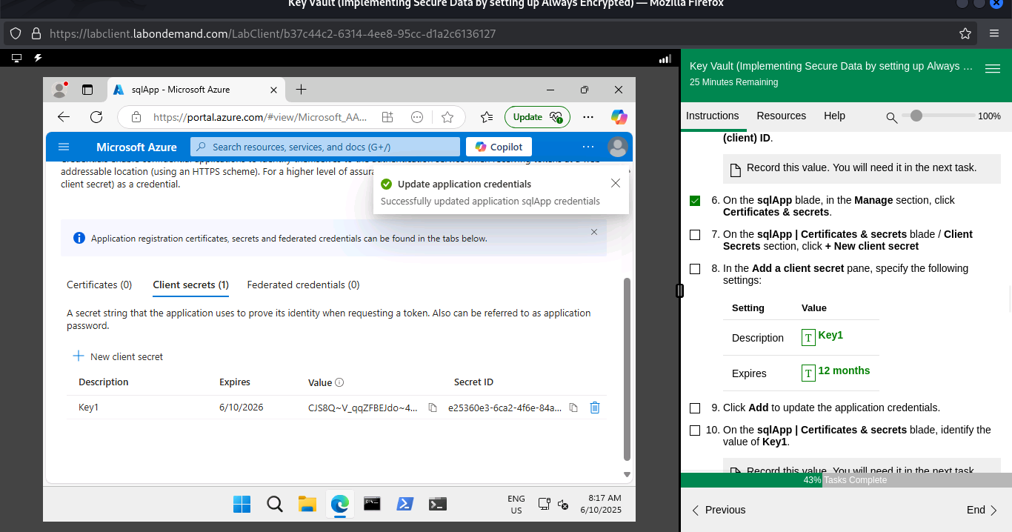

Task 2: Create a policy allowing the application access to the Key Vault.
In this task, you will grant the newly registered app permissions to access secrets stored in the Key Vault.
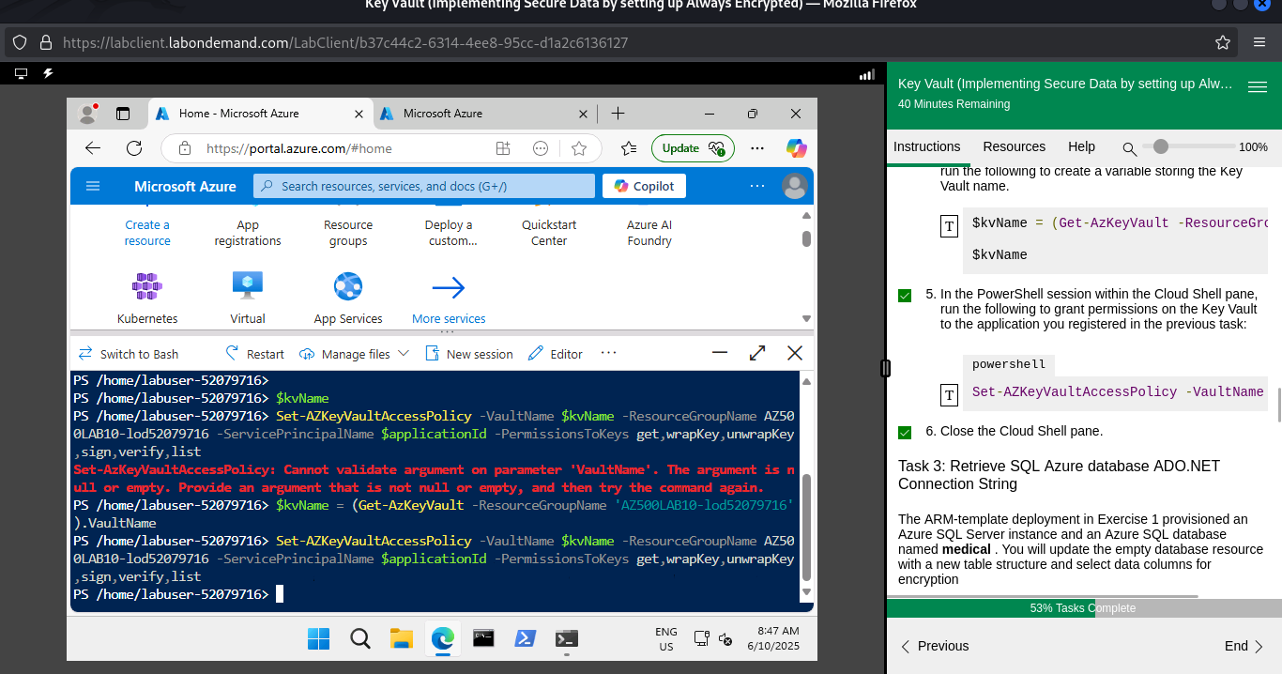

Task 3: Retrieve SQL Azure database ADO.NET Connection String
The ARM-template deployment in Exercise 1 provisioned an Azure SQL Server instance and an Azure SQL database named medical . You will update the empty database resource with a new table structure and select data columns for encryption
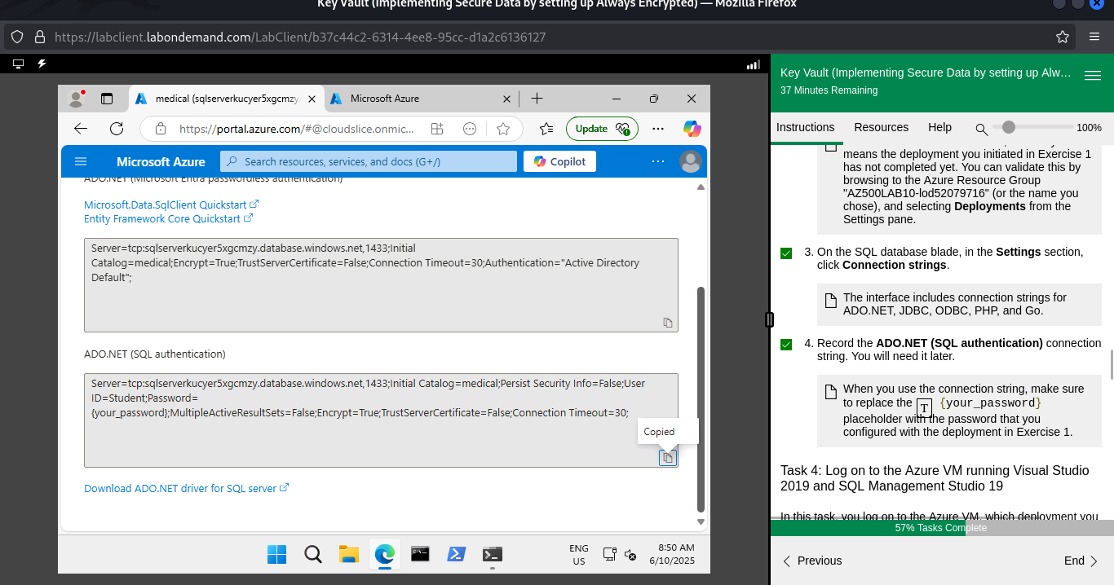

Task 4: Log on to the Azure VM running Visual Studio 2019 and SQL Management Studio 19
In this task, you log on to the Azure VM, which deployment you initiated in Exercise 1. This Azure VM hosts Visual Studio 2019 and SQL Server Management Studio 19.
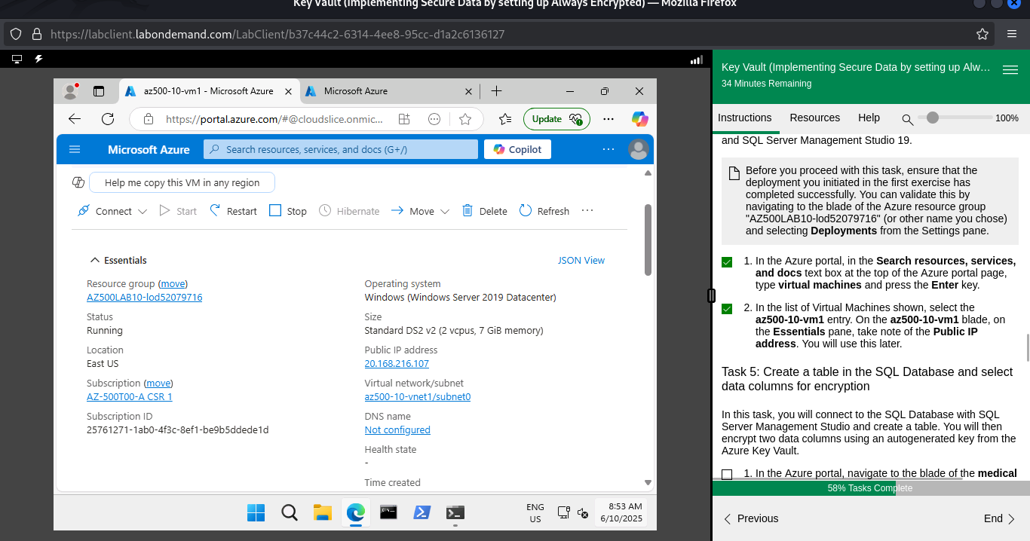

Task 5: Create a table in the SQL Database and select data columns for encryption
In this task, you will connect to the SQL Database with SQL Server Management Studio and create a table. You will then encrypt two data columns using an autogenerated key from the Azure Key Vault.
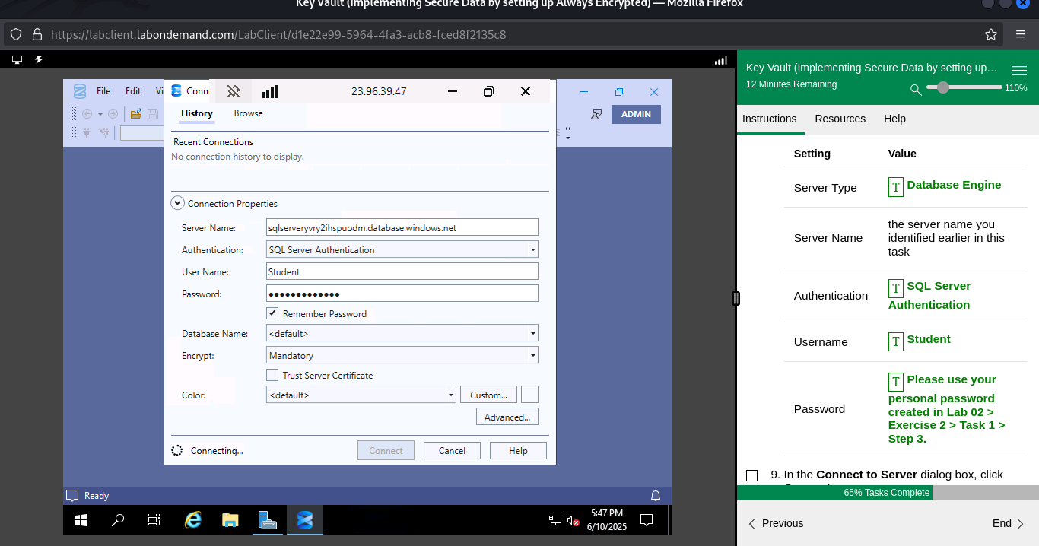
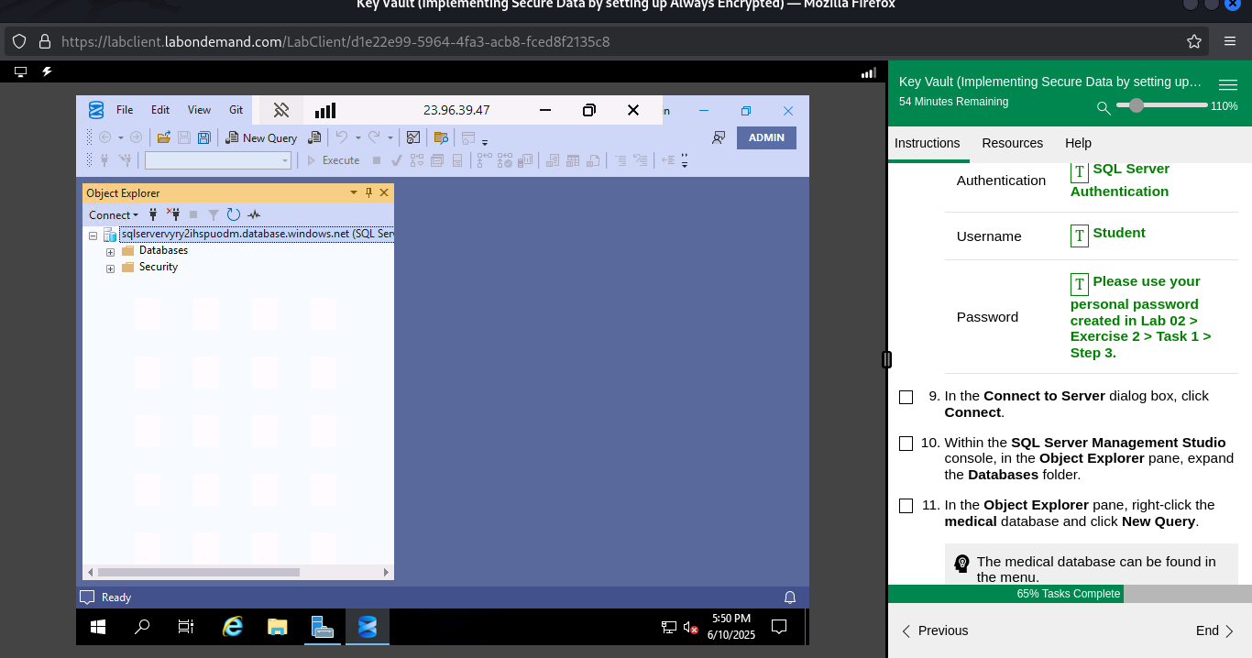
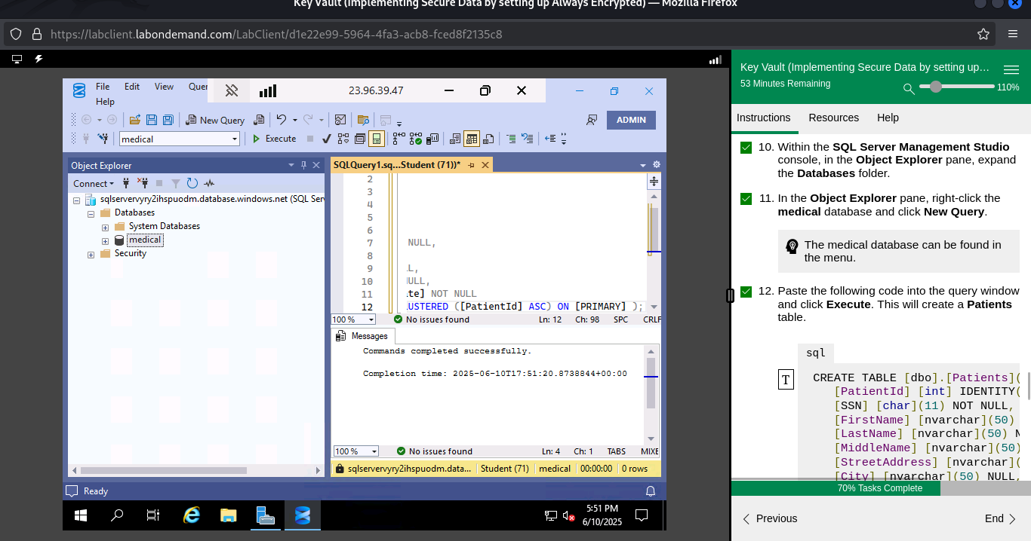
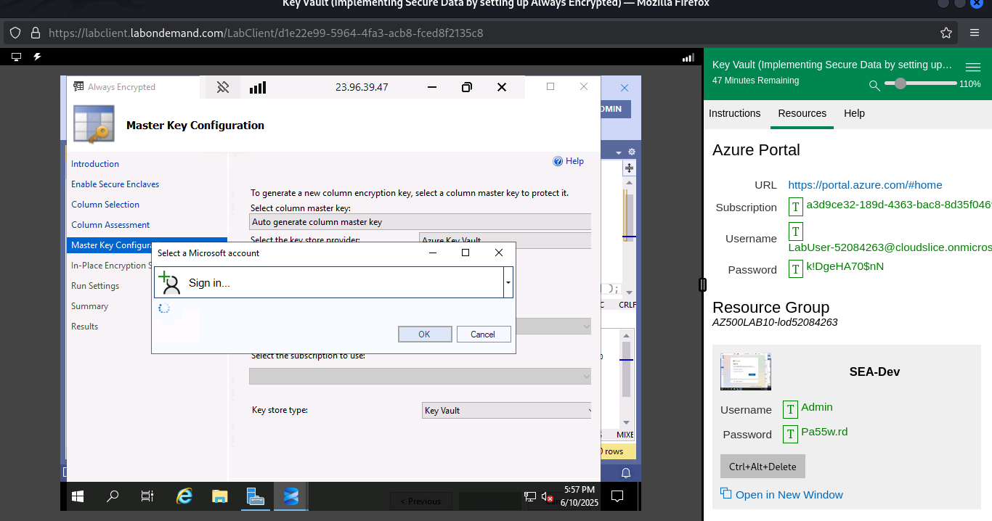
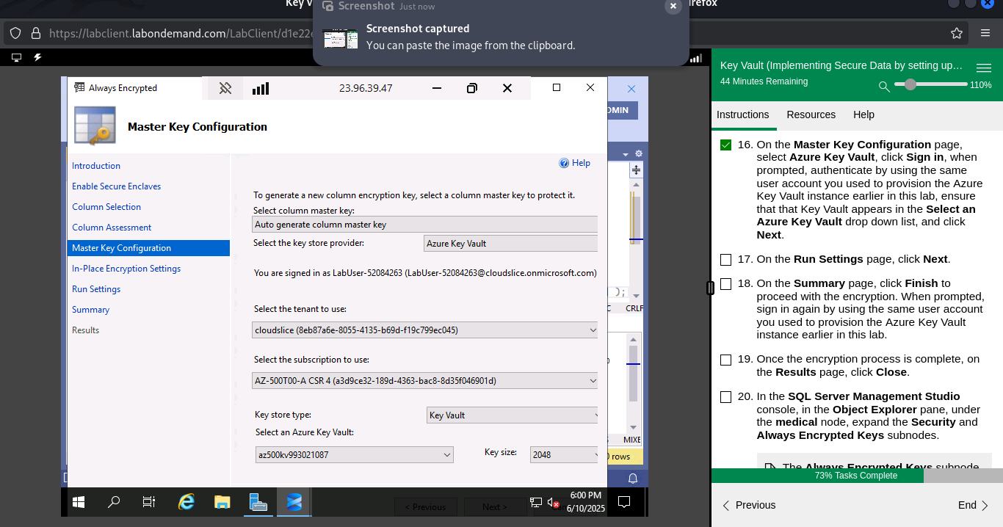
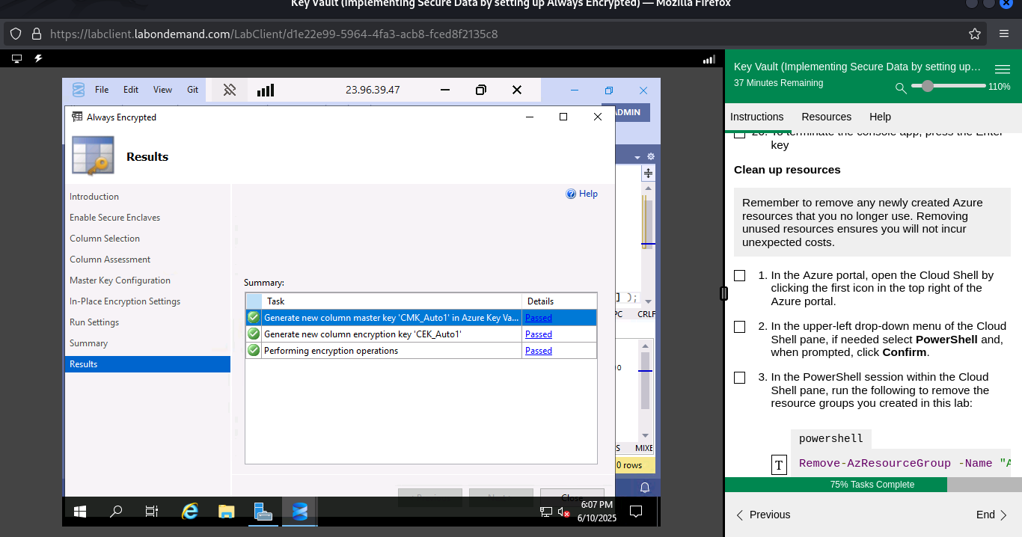
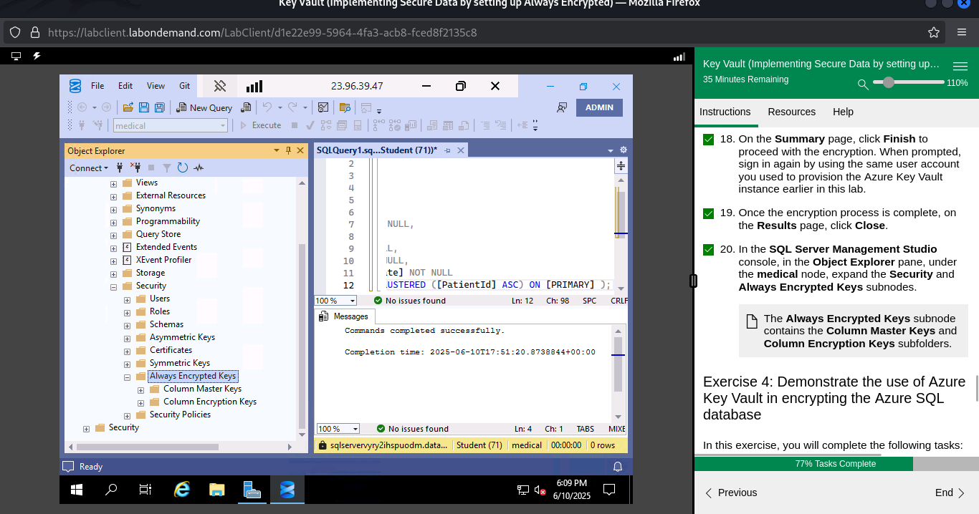

Exercise 4: Demonstrate the use of Azure Key Vault in encrypting the Azure SQL database
In this exercise, I completed the following tasks:
- Task 1: Run a data-driven application to demonstrate the use of Azure Key Vault in encrypting the Azure SQL database

Task 1: Run a data-driven application to demonstrate the use of Azure Key Vault in encrypting the Azure SQL database
You will create a Console application using Visual Studio to load data into the encrypted columns and then access that data securely using a connection string that accesses the key in the Key Vault.
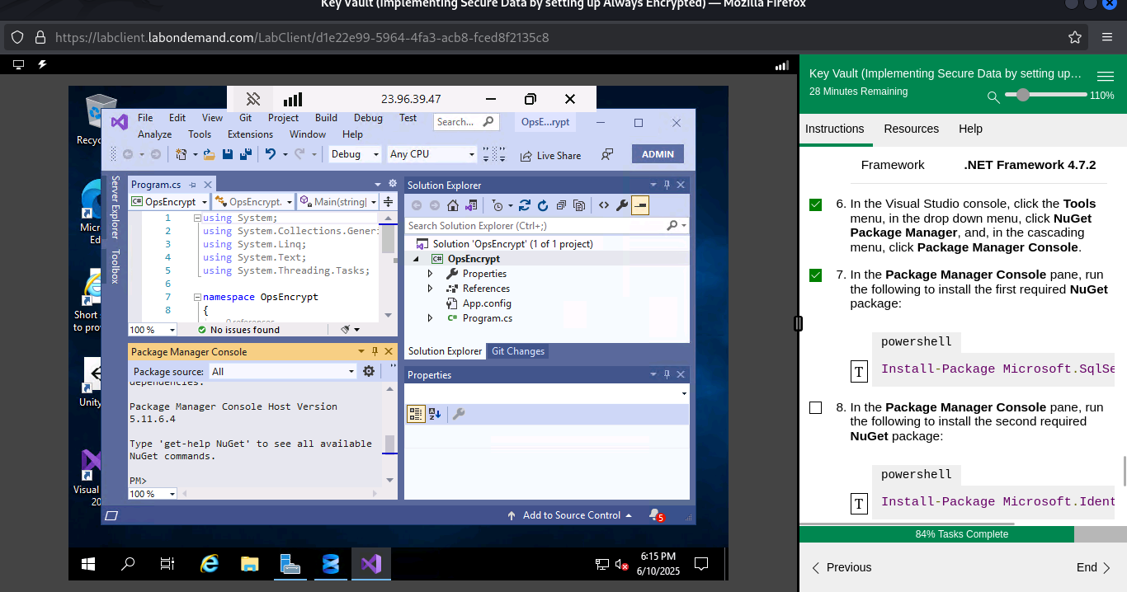
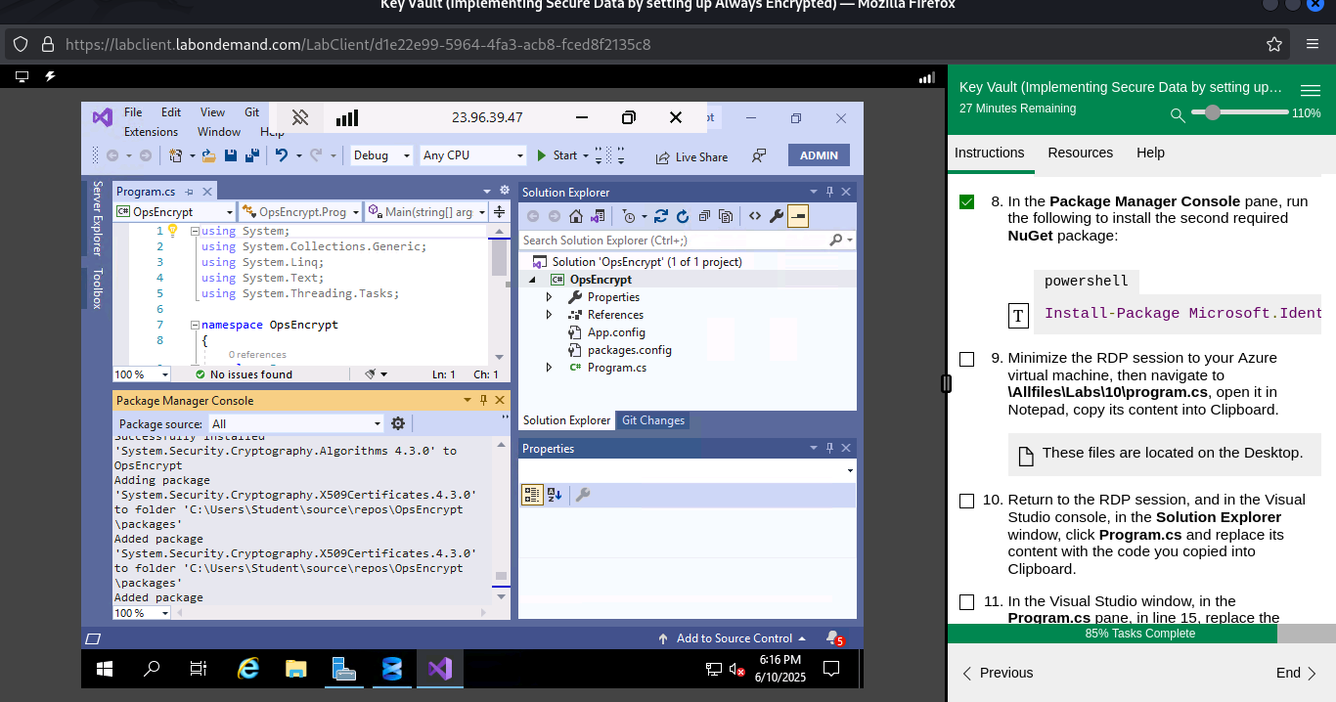
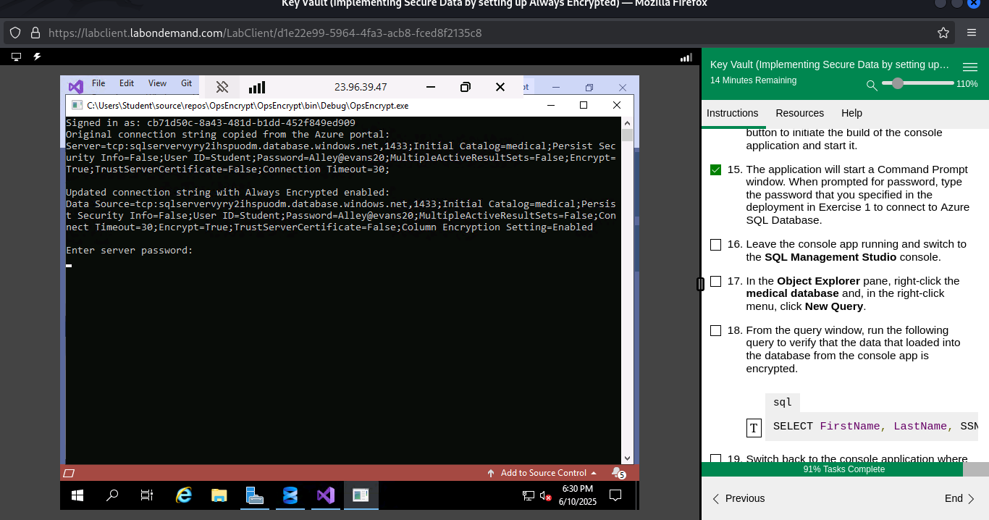
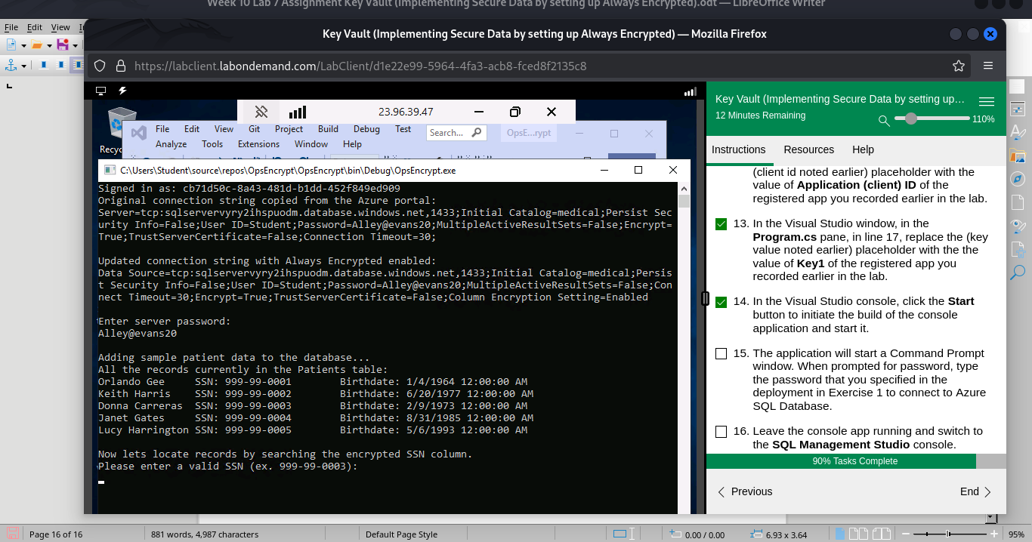
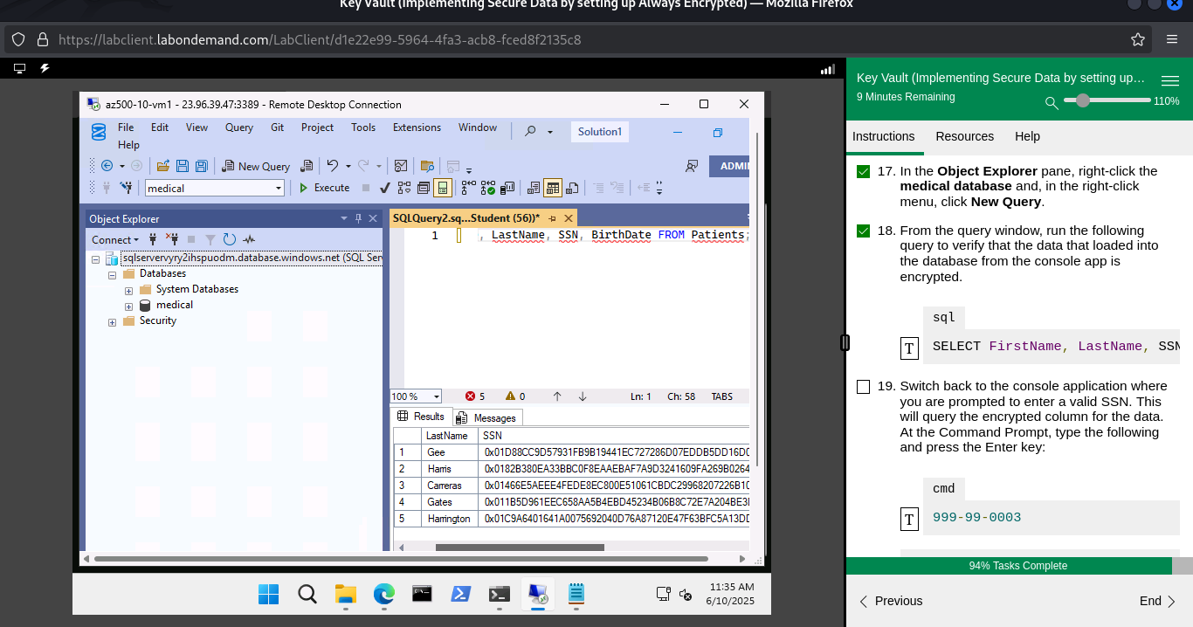
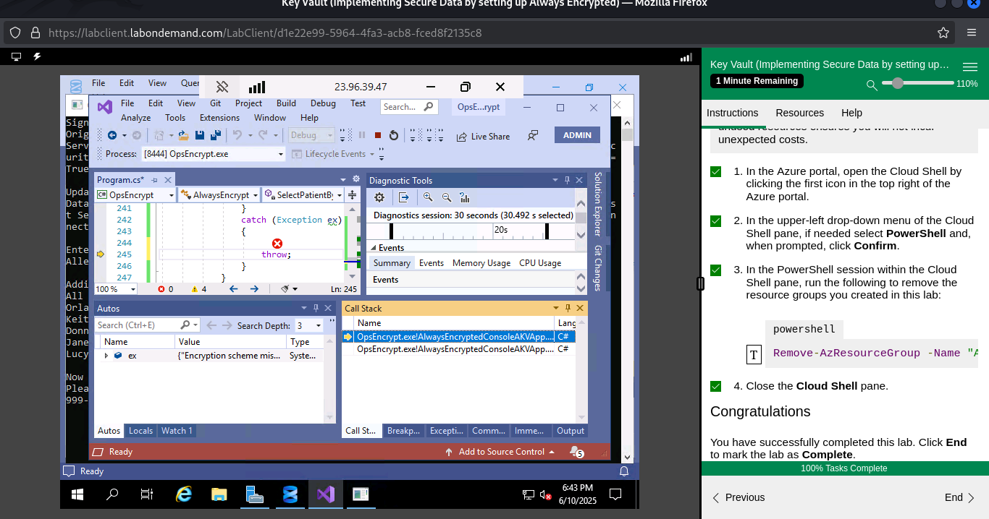
Summary
In this Lab I learned how to create an Azure key vault and how to Store Azure keys and secrets.
I also created a SQL Database and encrypted content of columns in database tables by using Always Encrypted.

